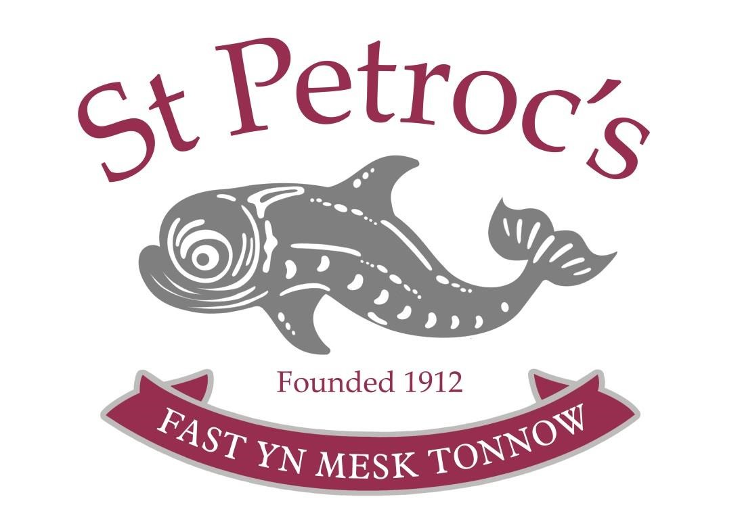

Risk Assessment Policy

Reviewed by the Governing Body 3rd December 2021

Next full review by the Governing Body November 2022

Change log:

DATE | Change(s) made | Page in policy | By  whom
26/1/2017 | Policy Reviewed and updated |  | AH
10/2/17 | Signed off by Governors
2/5/17 | Reviewed by Nick Buckland, Chair of Governors
4/12/17 | Reviewed by Alison Heywood, School Business Manager
8/2/18 | Policy reviewed by Governors and signed by Nick Buckland, Chair of Governors
13/2/19 | Policy reviewed by SBM  Circulated to SMT and Governors
13/02/2020 | Policy reviewed by SBM. Updated to reflect current practice.
03/12/21 | Reviewed by the Governing Body

Scope
This guidance is applicable to all those with responsibility for undertaking risk assessments for activities which are under their control. This includes the requirements of the Independent Schools Inspectorate and The Early Years Foundations Stage standards.
This policy will be systematic with a view to promoting children’s welfare and particular attention will be paid to key areas of risk such as supervision and educational visits. Please refer to the specific policies for these areas.

Objectives
- To ensure that suitable and sufficient risk assessments are undertaken for activities where there is likely to be significant risk
- That identified control measures are implemented to control risk so far as reasonably practicable
- That those affected by school activities have received suitable information on what to do
- That during risk assessments, significant findings are recorded and reviewed when appropriate

Guidance
The Early Years Manager will be responsible for the implementation of this policy.
This guidance is applicable to general risk assessment. Where specialist skills are required, e.g. asbestos, fire, water quality and hazardous substances, there is separate policy guidance in place. Teaching area risk assessment checklists are also in place for guidance.
All staff will receive guidance in September on risk assessment before they are required to complete one. This will be refreshed on an annual basis. Risk assessment training will be provided on specific areas where identified.
Risk assessments will take into account:
- Hazard - something with the potential to cause harm
- Risk - an evaluation of the likelihood of the hazard causing harm
- Risk rating - assessment of the severity of the outcome of an event
- Control measures - physical measures and procedures put in place to mitigate the risk
The risk assessment process will consist of the following 6 steps:
- What could go wrong?
- Who might be harmed?
- How likely is it to go wrong?
- How serious would it be if it did go wrong?
- What are you going to do to stop it or reduce the risk of it happening?
- How are you going to check that your plans are working?
The Early Years Manager will be responsible for the maintenance of risk assessment records.
Risk assessments will be reviewed:
- When there are changes to the activity
- After a near miss or accident
- When there are changes to the type of people involved in the activity
- When there are changes in good practice
- When there are legislative changes
- Annually if for no other reason (site/fire/science & PE department/classrooms & academic)

Legal Requirements & Education Standards
References:
A: Handbook for the Inspection of Schools - The Regulatory Requirements, Part 3 (www.isi.net)
B: Health & Safety Executive, “Controlling Risk in the Workplace”
(https://www.hse.gov.uk/risk/controlling-risks.htm)
C: “Health and Safety at Work” section of the ISBA Model Staff Handbook
D: “Health and Safety and Welfare at Work” chapter of the ISBA Bursar's Guide
E: Early Years Foundation Stage: Statutory Framework
F: Charities and Risk Management, The Charity Commission

